SCHOOL OF COMPUTER SCIENCE AND ARTIFICIAL INTELLIGENCE |  |  |  |  |  | DEPARTMENT OF COMPUTER SCIENCE ENGINEERING
 | Program Name: B. Tech |  |  |  | Assignment Type: Lab |  |  | Academic Year:2025-2026
 | Course Coordinator Name |  |  |  | Dr. Rishabh Mittal
 | Instructor(s) Name
  Mr. S Naresh Kumar
  Ms. B. Swathi
  Dr. Sasanko Shekhar Gantayat
  Mr. Md Sallauddin
  Dr. Mathivanan
  Mr. Y Srikanth
  Ms. N Shilpa
  Dr. Rishabh Mittal (Coordinator)
  Dr. R. Prashant Kumar
  Mr. Ankushavali MD
  Mr. B Viswanath
  Ms. Sujitha Reddy
  Ms. A. Anitha
  Ms. M.Madhuri
  Ms. Katherashala Swetha
  Ms. Velpula sumalatha
  Mr. Bingi Raju
 | Course Code |  |  | 23CS002PC304 | Course Title |  | AI Assisted Coding
 | Year/Sem |  |  | III/II | Regulation |  | R23
 | Date and Day  of Assignment |  |  | Week3 – Wednesday | Time(s) |  | 23CSBTB01 To 23CSBTB52
 | Duration |  |  | 2 Hours | Applicable to  Batches |  | All batches
AssignmentNumber:6.3(Present assignment number)/24(Total number of assignments)
 |  | Q.No. | Question |  |  |  |  |  | Expected Time  to complete
 |  | 1 | Lab 6: AI-Based Code Completion – Classes, Loops, and Conditionals  Lab Objectives  • To explore AI-powered auto-completion features for core Python constructs such as classes, loops, and conditional statements.  • To analyze how AI tools suggest logic for object-oriented programming and control structures.  • To evaluate the correctness, readability, and completeness of AI-generated Python code.  Lab Outcomes (LOs)  After completing this lab, students will be able to:  • Use AI tools to generate and complete Python class definitions and methods.  • Understand and assess AI-suggested loop constructs for iterative tasks.  • Generate and evaluate conditional statements using AI-driven prompts.  • Critically analyze AI-assisted code for correctness, clarity, and efficiency.  Task Description #1: Classes (Student Class)  Scenario  You are developing a simple student information management module.  Task  • Use an AI tool (GitHub Copilot / Cursor AI / Gemini) to complete a Student class.  • The class should include attributes such as name, roll number, and branch.  • Add a method display_details() to print student information.  • Execute the code and verify the output.  • Analyze the code generated by the AI tool for correctness and clarity.  Expected Output #1  • 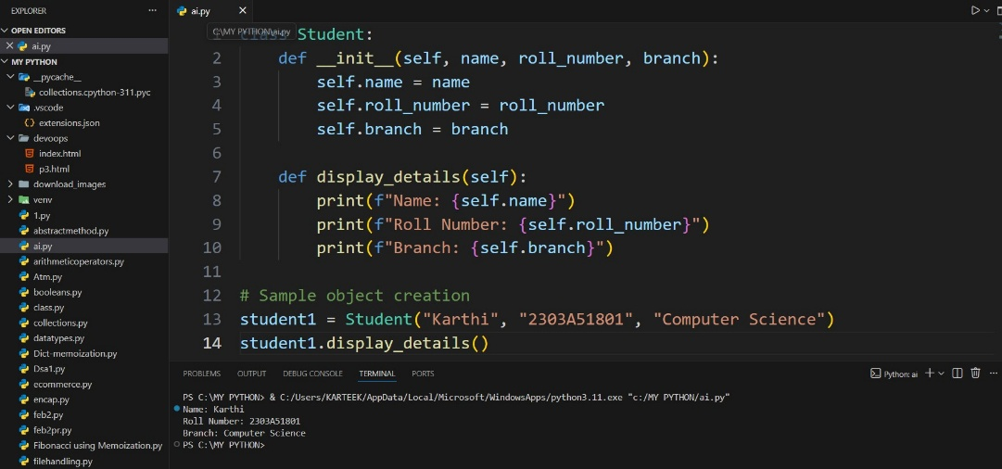  Task Description #2: Loops (Multiples of a Number)  Scenario  You are writing a utility function to display multiples of a given number.  Task  • Prompt the AI tool to generate a function that prints the first 10 multiples of a given number using a loop.  • Analyze the generated loop logic.  • Ask the AI to generate the same functionality using another controlled looping structure (e.g., while instead of for).  Expected Output #2  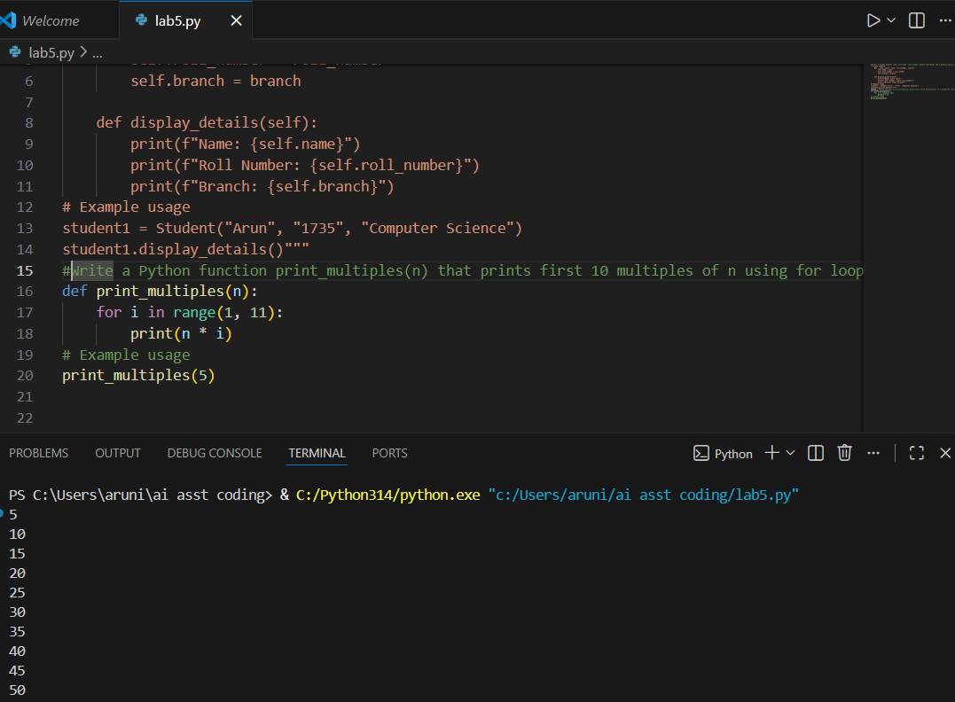.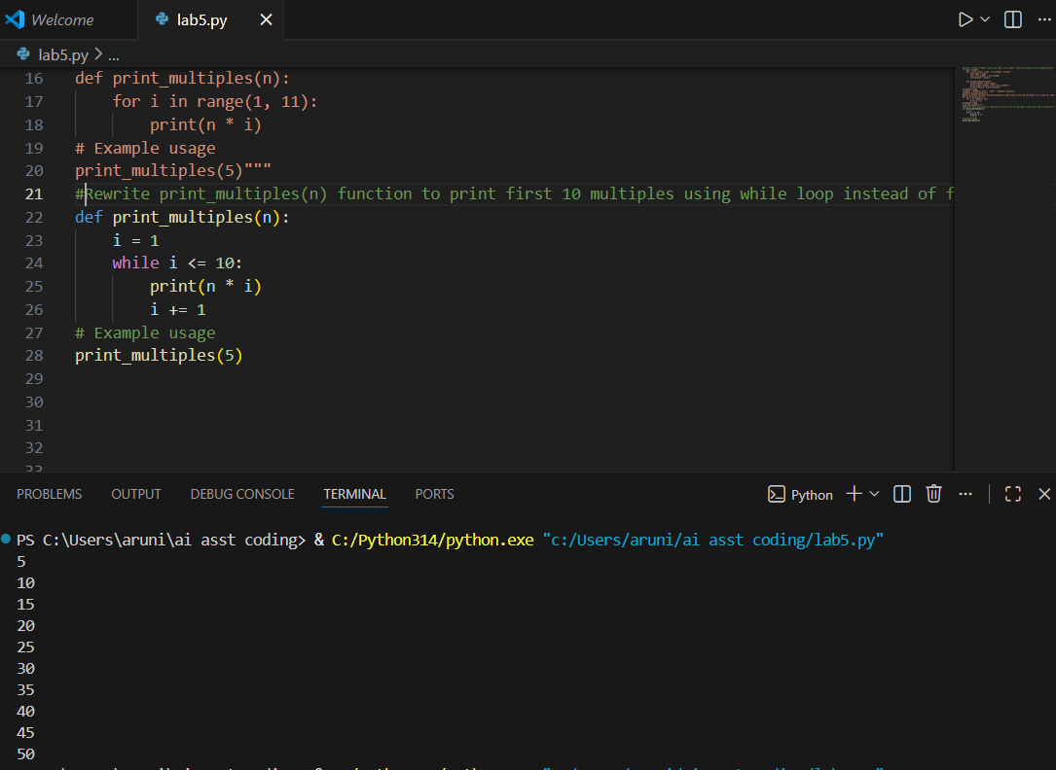  Task Description #3: Conditional Statements (Age Classification)  Scenario  You are building a basic classification system based on age.  Task  • Ask the AI tool to generate nested if-elif-else conditional statements to classify age groups (e.g., child, teenager, adult, senior).  • Analyze the generated conditions and logic.  • Ask the AI to generate the same classification using alternative conditional structures (e.g., simplified conditions or dictionary-based logic).  Expected Output #3  •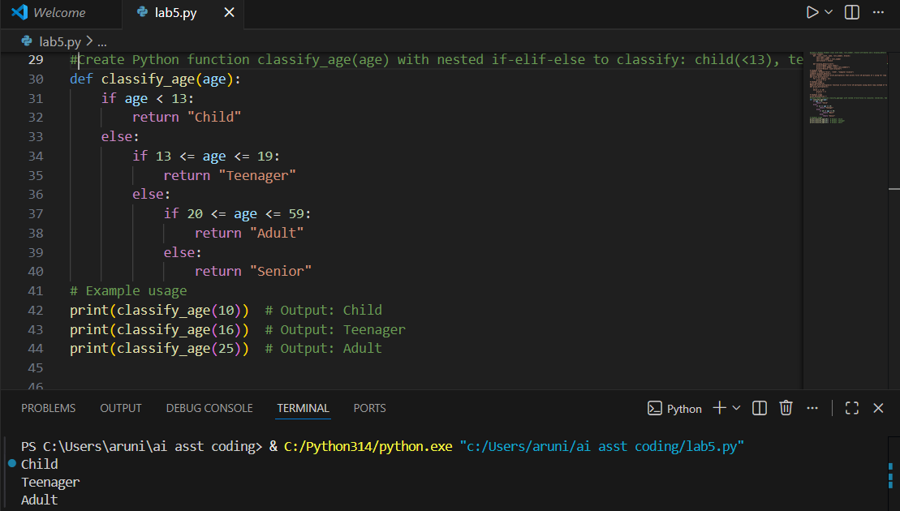  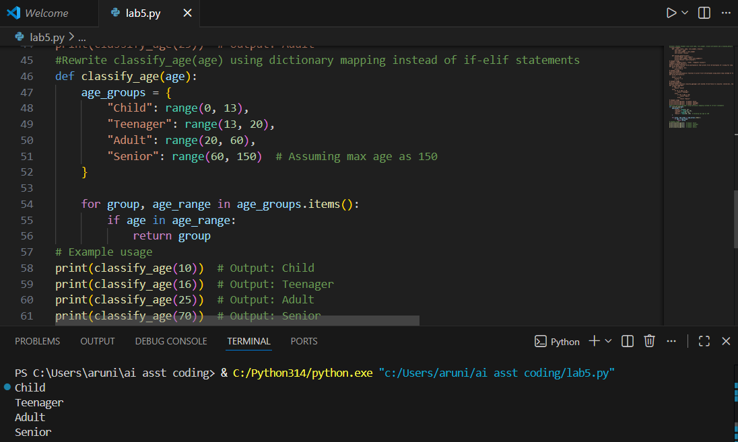  Task Description #4: For and While Loops (Sum of First n Numbers)  Scenario  You need to calculate the sum of the first n natural numbers.  Task  • Use AI assistance to generate a sum_to_n() function using a for loop.  • Analyze the generated code.  • Ask the AI to suggest an alternative implementation using a while loop or a mathematical formula.  Expected Output #4  •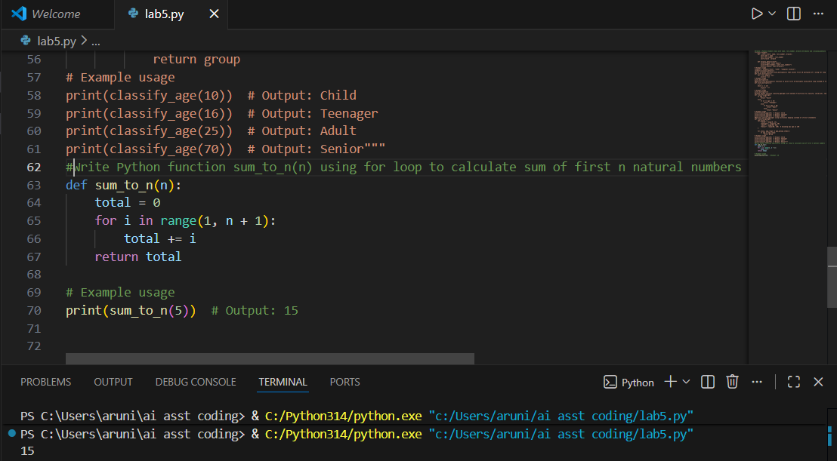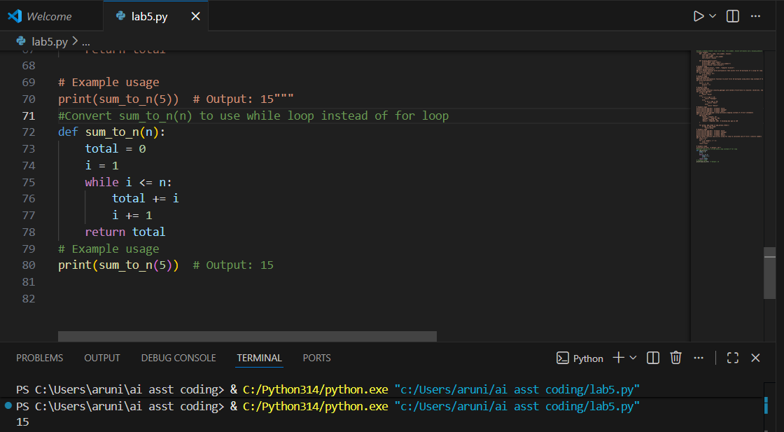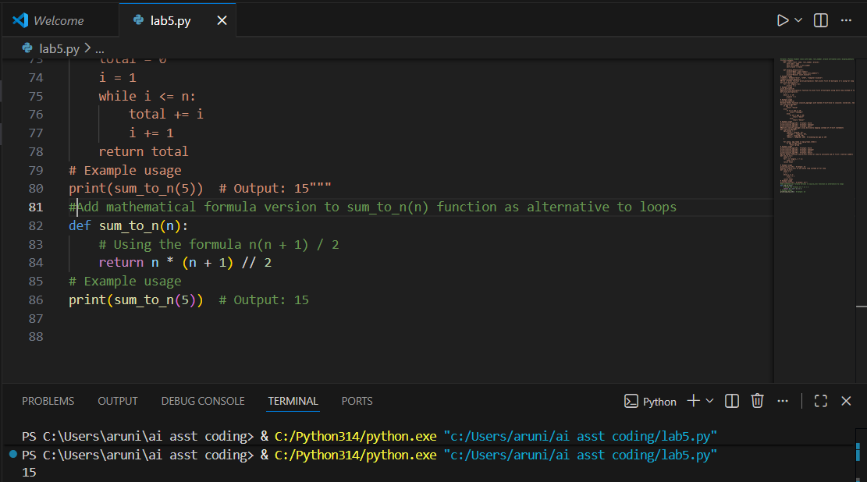.  Task Description #5: Classes (Bank Account Class)  Scenario  You are designing a basic banking application.  Task  • Use AI tools to generate a Bank Account class with methods such as deposit(), withdraw(), and check_balance().  • Analyze the AI-generated class structure and logic.  • Add meaningful comments and explain the working of the code.  Expected Output #5  • 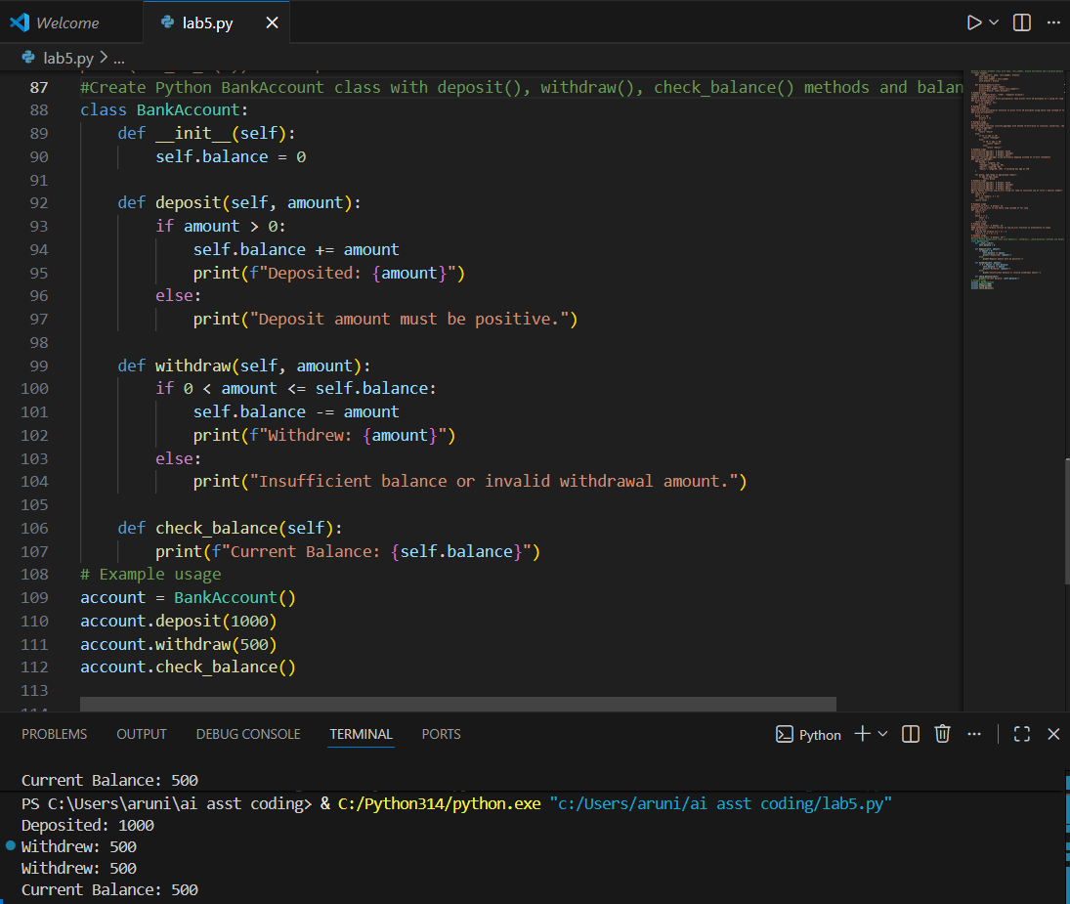.  Note: Report should be submitted as a word document for all tasks in a single document with prompts, comments & code explanation, and output and if required, screenshots. |  |  |  |  |  | Week3 - Wednesday

